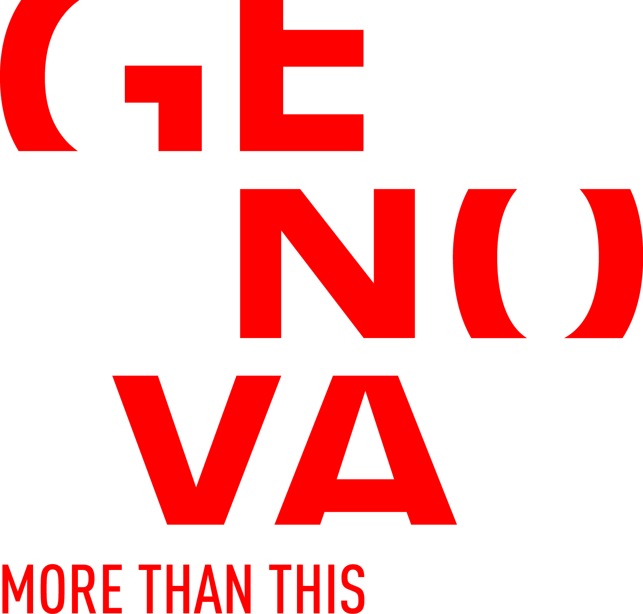  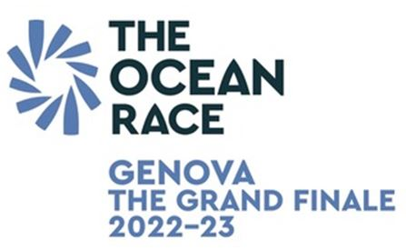 | 

Form for submission of proposals within the project
"Sala Dogana. New ideas in movement"

Proposer and involved artists:

Date of birth of all participants:

Brief curriculum of the proposer:

Brief curriculum of all the artists :

Contact of the proposer:
address
phone
e-mail
website

Contact of all the artists:
address
phone
e-mail
website

Title and artistic field of the proposal:


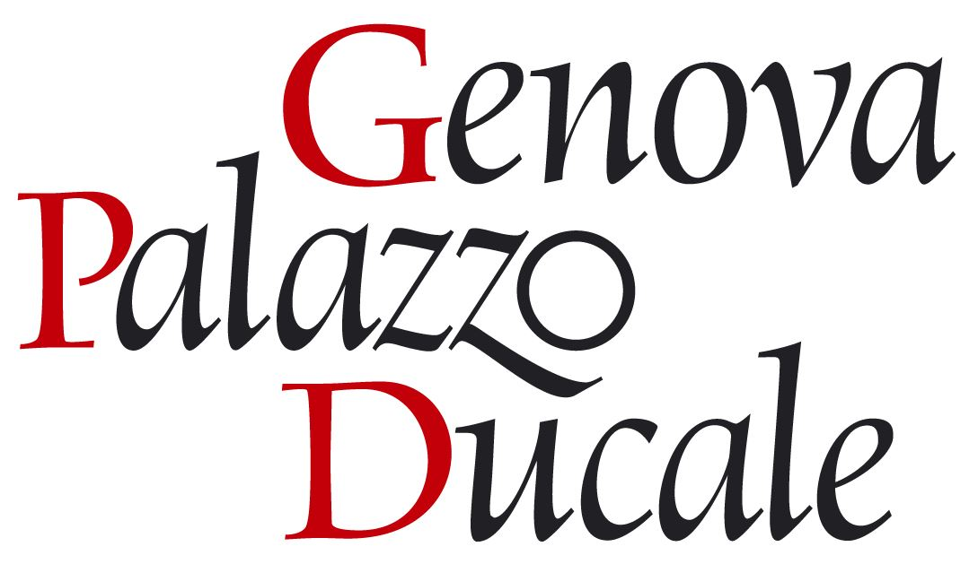



Description (maximum one page):

Target to which it is addressed :
(the activities of the Sala Dogana are all free admission , therefore it is required to indicate whether the contents of the proposal are suitable for all audiences)

Other individuals and organizations involved:

Technical requirements (equipment, materials and other necessities,… ):

Timing:
quantify the time from proposal to acceptance realization;
quantify the days of setting up and dismantling;
indicate, for information only, the desired period of execution and timetable

Attachments:
list the materials submitted with the application
(textual material, video, photo, etc.)

n.b. Please note that the in-depth materials are not optional and that the Commission will only select proposals documented in such a way that makes understandable the content of what will be exhibited/propose in room.

SPECIFY:
- Production of other promotional materials and / or documentation;
- Visibility type required by the sponsor, if applicable;
- Catering;
- Workshops prevision or other collateral activities;
- Other

